4MP WIFI Bullet Network Camera

IPC2124LR3-F40W-D
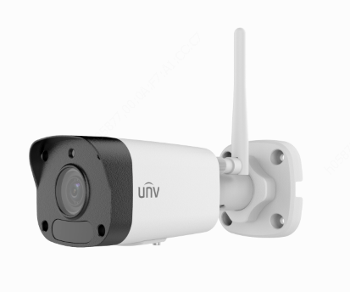

Key Features

Optics
  - Day/night functionality
  - Smart IR , up to 30 m (98 ft) IR distance
  - Optical glass window with higher light transmittance
  - IR anti-reflection window to increase the infrared transmittance
  - 2D/3D DNR (Digital Noise Reduction)

Compression
  - Ultra 265,H.265, H.264, MJPEG
  - Triple streams

Network
  - ONVIF Conformance

Structure
  - Wide temperature range:-30°C ~ +60°C (-22°F ~ 140°F)
  - Wide voltage range of ±25%
  - IP67

Specifications
 |  | IPC2124LR3-F40W-D
Camera
Sensor |  | 1/2.7", 4.0 megapixel, progressive scan, CMOS
Lens |  | 4.0mm@F2.0
DORI Distance |  | Lens | Detect(m) | Observe(m) | Recognize(m) | Identify(m)
 |  | 4mm | 80 | 32 | 16 | 8
Angle of view(H) |  | 86.5°
Angle of View (V) |  | 44.1°
Angle of View (O) |  | 106.4°
Shutter |  | Auto/Manual, 1~1/100000 s
Minimum Illumination |  | Colour: 0.02 Lux (F2.0 AGC ON)  0 Lux with IR on
Day/Night |  | IR-cut filter with auto switch (ICR)
Digital noise reduction |  | 2D/3D DNR
S/N |  | >52dB
IR Range |  | Up to 30m (98 ft) IR range
Defog |  | Digital Defog
WDR |  | DWDR
Video
Video Compression |  | Ultra 265, H.265, H.264, MJPEG
H.264 code profile |  | Baseline profile, Main Profile
Frame Rate |  | Main Stream: 4MP (2560×1440): Max. 15 fps; 2MP (1920×1080): Max. 15 fps;  Sub Stream: 720P (1280×720): Max. 15 fps;  Third Stream: 4CIF (704×576): Max. 15 fps
HLC |  | Supported
BLC |  | Supported
OSD |  | Up to 4 OSDs
Privacy Mask |  | Up to 4 areas
ROI |  | Up to 2 areas
Motion Detection |  | Up to 4 areas
Smart
Behavior Detection | Intrusion, Motion detection,Tampering alarm
Intrusion | Enter and loiter in a pre-defined virtual region
Storage
Edge Storage |  | Micro SD, up to 256 GB
Network Storage |  | ANR
Network
Protocols |  | IPv4, IGMP, ICMP, ARP, TCP, UDP, DHCP, RTP, RTSP, RTCP, DNS, DDNS, NTP, FTP, UPnP, HTTP, HTTPS, SMTP,QoS
Compatible Integration |  | ONVIF(Profile S, Profile G, Profile T), API
Wi-Fi
Wireless Standards |  | IEEE802.11b/g/n
Frequency Range |  | 2.4 GHz ~ 2.4835 GHz
Channel Bandwidth |  | 20 MHz Support
Modulation Mode |  | 802.11b: CCK, QPSK, BPSK  802.11g/n: OFDM/HT
Security |  | 64/128-bit WEP, WPA-PSK/WPA2-PSK
Transmit Power |  | 802.11b: 17±1.5dBm @11Mbps  802.11g: 14±1.5dBm @ 54Mbps  802.11n: 12.5±1.5dBm @150Mbps
Receive Sensitivity |  | 802.11b: -90dBm @11Mbps (Typical)  802.11g: -75dBm @54Mbps (Typical)  802.11n: -74dBm @150Mbps (Typical)
Transmission Rate |  | 802.11b: 11Mbps  802.11g: 54Mbps  802.11n: up to 150Mbps
Interface
Network |  | 1 RJ45 10M/100M Base-TX Ethernet
General
Power |  | DC 12V±25%
 |  | Power consumption: Max 4 W
Dimensions (L × W × H) |  | 161.1 × 62.4 ×62.7 mm (6.3” × 2.5” × 2.5”)
Weight |  | 0.25 kg (0.55 lb)
Working Environment |  | -30°C ~ +60°C (-22°F ~ 140°F), Humidity: ≤95% RH(non-condensing)
Ingress Protection |  | IP67
Reset Button |  | Supported
Indicator Light |  | Supported

Dimensions
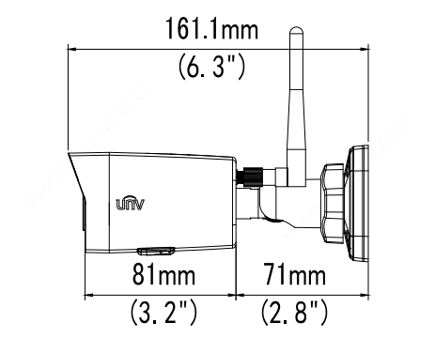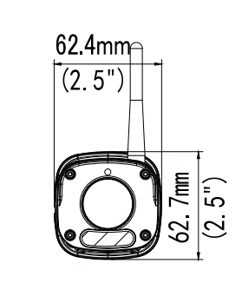
Zhejiang Uniview Technologies Co., Ltd.
Building No.10, Wanlun Science Park, Jiangling Road 88, Binjiang District, Hangzhou, Zhejiang, China
Email: overseasbusiness@uniview.com; globalsupport@uniview.com
http://www.uniview.com
©2019 Zhejiang Uniview Technologies Co.,Ltd. All rights reserved.
*Product specifications and availability are subject to change without notice.

